Date: [Insert date]
Dear [Insert Dr. name],
Re: [Insert child’s name]
DOB: [Insert]
I am writing to you regarding [Insert], as this child’s school-based/community occupational therapist. He/she was seen recently for an occupational therapy consultation, related to school concerns regarding [Insert] (e.g., printing, poor fine motor skills and/or decreased participation in gym).

During the consultation, this child displayed many of the characteristics shown by children with Developmental Coordination Disorder (DCD).

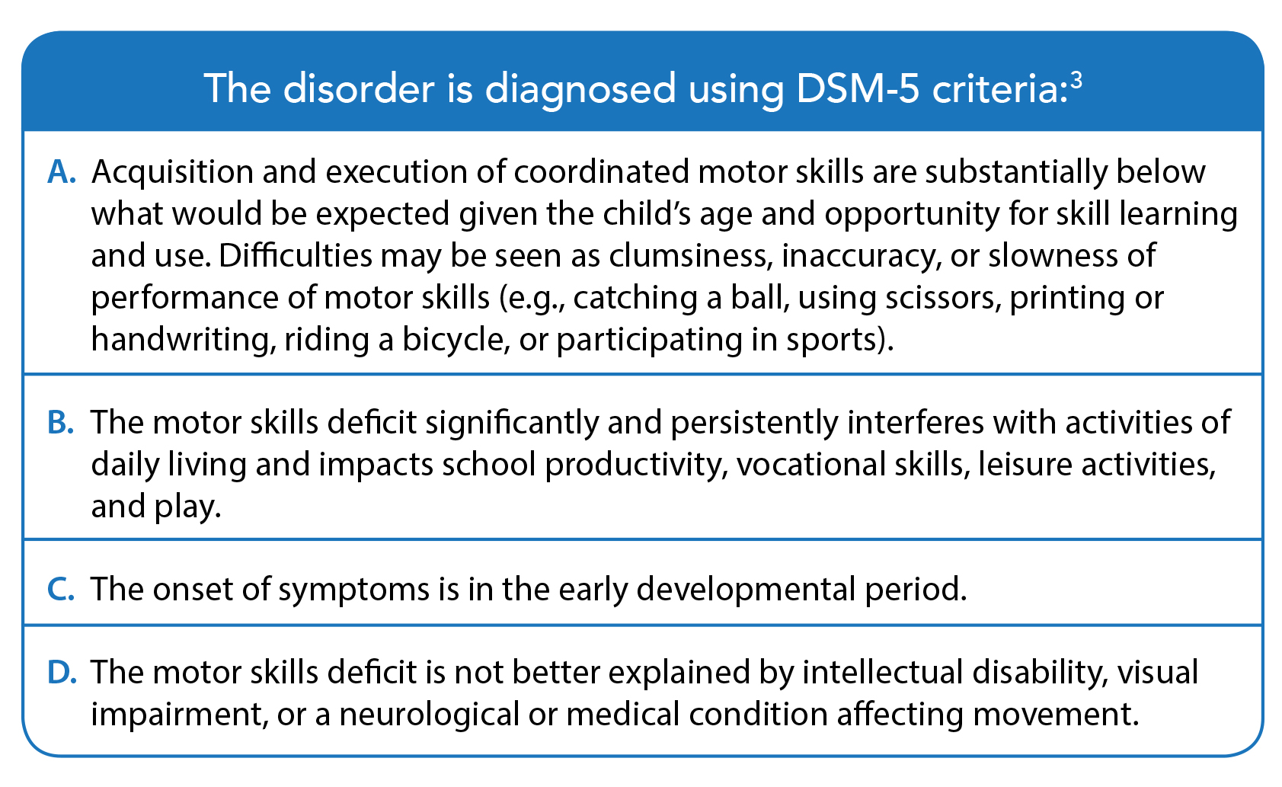
Occupational therapy clinical findings
Best practice for DCD assessment includes an assessment of motor skills by an occupational therapist. Findings from my clinical assessment were as follows: [instructions: enter actual findings below, and delete or replace information that is not relevant]
Criterion A: This child’s motor skills are substantially below that expected given the child’s age and opportunities for skill learning and practice. Standardized testing confirmed that this child is scoring [at or below the 16th percentile OR at or below the 5th percentile for [fine or gross] motor skills (for children 6 years and older) OR at or below the 5th percentile (for those 3-5 years) OR ≤ 5th on manual dexterity or balance, which may be indicative of DCD if all other diagnostic criteria are met].

Criterion B: A screening questionnaire completed by the parents, the Developmental Coordination Disorder Questionnaire (DCDQ), placed the child in the [“indication of DCD” OR “suspected DCD range”].

Criterion C: Parents reported a history of motor difficulties, including [e.g., difficulty in learning age-appropriate motor skills, such as tying shoelaces, riding a bicycle, passing swimming lessons]. The attached “Listening for DCD Checklist”³ may also support assessment of this criterion.
Criterion D: A medical examination is required to rule out other possible explanations for the child’s motor difficulties. Cognitive abilities do not need to be formally assessed (i.e., IQ testing) if there is a normal history of school functioning and academic achievements; however, if any uncertainly exists regarding normal cognitive functioning, standardized testing by a psychologist is recommended.²
Please see attached report for detailed assessment findings.
Next steps
I am writing to you to request further medical consultation to investigate this possible diagnosis of Developmental Coordination Disorder so that the correct supports, adaptations, and appropriate interventions can be put into place both at school and at home.
This diagnostic consideration is needed to avoid the debilitating effects of DCD, which typically impact not only daily living and academic functioning, but also social relationships, participation and psychological issues, including depression and anxiety. Consequently, the quality of life of children and youth with DCD can be considerably compromised. Diagnosis will help the family and school team better understand and advocate for appropriate intervention for their child.
Please do not hesitate to contact me if you have any questions or concerns regarding the above.
Sincerely,

___________________________
[Insert name of occupational therapist and sign above]

References
- American Psychiatric Association. Diagnostic and statistical manual of mental disorders (5th ed.). Arlington, VA. 2013
- Blank R, Smits-Engelsman B, Polatajko H, Wilson P. European Academy for Childhood Disability (EACD): recommendations on the definition, diagnosis, and intervention of developmental coordination disorder (long version). Dev Med Child Neurol. 2012;54:54–93.
- Camden C, Rivard L, Pollock, Missiuna C. Listening for DCD Interview Guide. CanChild. 2013; Available from: http://bit.ly/2Ca1qDw

